1. Before discussing what is Dependency Injection, we need to discuss what is Dependency and what is injection.
2. 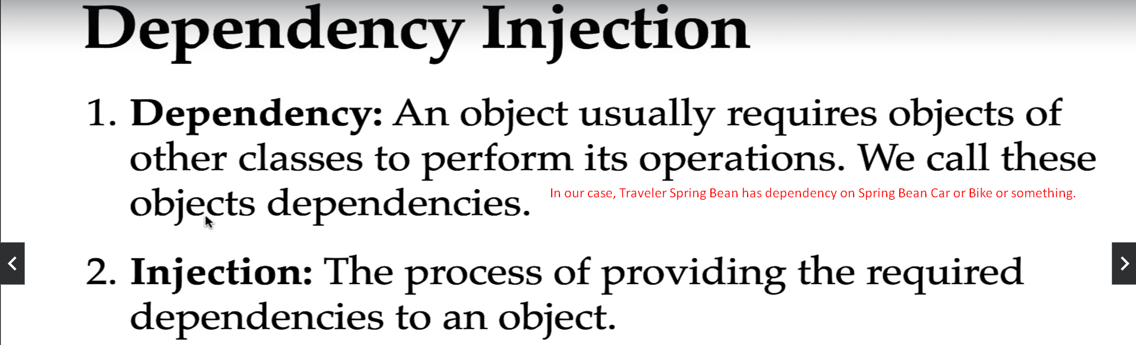  
   Let us discuss now Dependency Injection.
3. The entire process of identifying an object creating it and its dependencies and wiring them together is known as **Dependency Injection**.  
   The DI (Dependency Injection) also **called inversion of control** as the control is inverted from us to framework.

DI (Dependency Injection) = Inversion of Control (IoC)

1. **For Example**:   
   Spring Framework is **Dependency Framework** as it creates object and its all dependencies and wire the dependencies into the object.
2. 